|  |  |
| --- | --- |
| Exp no: | FILE ALLOCATION ALGORITHM |
| Date: |

# AIM:

# DESCRIPTION:

|  |  |
| --- | --- |
| Exp no: | SEQUENTIAL ALLOCATION |
| Date: |

# AIM:

# ALGORITHM:

## SOURCE CODE FOR SEQUENTIAL ALGORITHM:

#include<stdio.h>

#include<stdlib.h>

int main()

{

int f[50],i,st,j,len,c,k;

for(i=0;i<50;i++) f[i]=0;

X:

printf("\n Enter the starting block & length of file");

scanf("%d%d",&st,&len);

for(j=st;j<(st+len);j++)

if(f[j]==0)

{

f[j]=1

;

printf("\n%d->%d",j,f[j]);

}

else

{

printf("Block already allocated");

break;

}

if(j==(st+len))

printf("\n the file is allocated to disk");

scanf("%d",&c);

if(c==1)

goto X;

else

exit;

}

## Output:

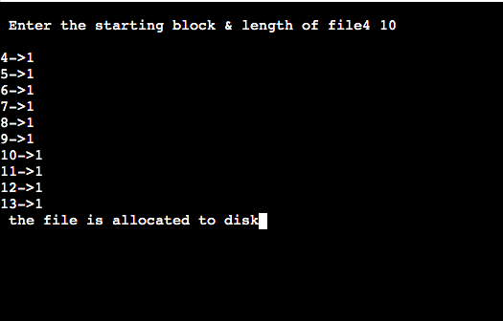

Result:

|  |  |
| --- | --- |
| EXP NO: | INDEXED ALGORITHM |
| DATE: |

# AIM:

# ALGORITHM:

# SOURCE CODE:

#include<stdio.h>

#include<stdlib.h>

int f[50],i,k,j,inde[50],n,c,count=0,p;

int main()

{

for(i=0;i<50;i++)

f[i]=0;

x: printf("enter index block: ");

scanf("%d",&p);

if(f[p]==0)

{

f[p]=1;

printf("enter no of files on index: ");

scanf("%d",&n);

}

else

{

printf("Block already allocated\n");

goto x;

}

for(i=0;i<n;i++)

scanf("%d",&inde[i]);

for(i=0;i<n;i++)

if(f[inde[i]]==1)

{

printf("Block already allocated");

goto x;

}

for(j=0;j<n;j++)

f[inde[j]]=1;

printf("ALLOCATED\n");

printf("file indexed\n");

for(k=0;k<n;k++)

printf("\n %d->%d:%d",p,inde[k],f[inde[k]]);

printf(" \nEnter 1 to enter more files and 0 to exit\t");

scanf("%d",&c);

if(c==1)

goto x;

else

exit;

}

# Output:

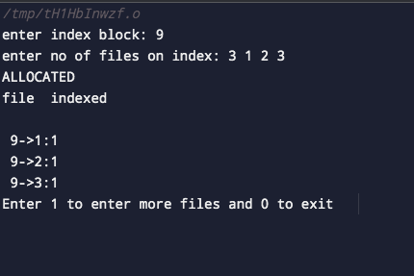

# Result:

|  |  |
| --- | --- |
| Exp no: | LINKED ALGORITHM |
| Date: |

# AIM:

# ALGORITHM:

# SOURCE CODE:

#include<stdio.h>

#include<stdlib.h>

int main()

{

int f[50],p,i,j,k,a,st,len,n,c;

for(i=0;i<50;i++) f[i]=0;

printf("Enter how many blocks that are already allocated: ");

scanf("%d",&p);

printf("\nEnter the blocks no.s that are already allocated: ");

for(i=0;i<p;i++)

{

scanf("%d",&a);

f[a]=1;

}

X:

printf("Enter the starting index block &length: ");

scanf("%d%d",&st,&len); k=len; for(j=st;j<(k+st);j++)

{

if(f[j]==0)

{ f[j]=1;

printf("\n%d->%d",j,f[j]);

}

else

{

printf("\n %d->file is already allocated",j);

k++;

}

}

printf("\n If u want to enter one more file? (yes-1/no-0)");

scanf("%d",&c);

if(c==1)

goto

X;

else

exit;

}

Output:

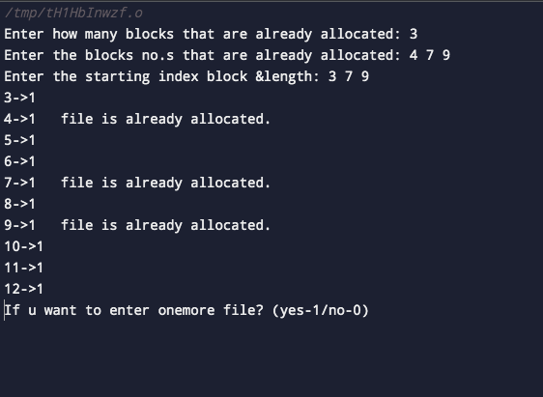

Result: